ECE 390 Lecture Notes 1

# Engineering Costs

## Types of Engineering Costs

* Fixed cost: constant, unchanging – doesn’t depend on output
* Variable cost: depends on amount of output/activity
* Total cost: sum of fixed cost and variable cost

Example: A company produces a single, high-volume product. One year, its production volume was 780,000 units, its fixed costs were $3.2 million, and its variable costs were $16 per unit. What was the company's total cost for the year?

$$Total cost=\$3 200 000+\$16×780 000=\$15 680 000$$

* Marginal cost: variable cost for one more unit of output
* Average cost: total cost / number of units

Example: A product has a fixed cost of $3000 and the employees are paid $200 per unit for the first 10 units, then they are paid an overtime at 150% of their hourly rate after that. Calculate the total, marginal and the average cost for producing 5 units. Also calculate the marginal cost for producing 12 units and the average cost for this production level.

**5 units:**

$$Total cost=\$3000+\$200×5=\$4000$$

$$Marginal cost=\$200/unit$$

$$Average cost=\frac{\$4000}{5 units}=\$800$$

**12 units:**

$$Total cost=\$3000+\$200×10+\$200×1.5×2=\$5600$$

$$Marginal cost=\$200×1.5=\$300/unit$$

$$Average cost=\frac{\$5600}{12 units}=\$466.67$$

* Sunk cost: money already spent, as result of past decision – nothing can be done to change this cost
* Opportunity cost: cost of resource being used for an alternate task – potential gains forgone by forgoing one activity for another

Example: Three years ago, an engineering student purchased a notebook PC for $2,800. The student now wishes to sell the computer.

* The $2,800 initial cost is a sunk cost, because is irrelevant and should not play a part in deciding the selling price.

Example: Suppose a product distributor decides to construct a new distribution center instead of leasing a building. Leasing a building immediately would have resulted in a $12,000 product distribution cost savings during the next 6 months while the new warehouse is being constructed.

* + By forgoing the warehouse leasing alternative, the distributor experiences an opportunity cost of $12,000.

Example: A ‘lot’ of old electric pumps, purchased 3 years ago, by a distributor

1. Price 3 years back = $7,000 🡪 sunk cost (already paid)
2. Storage cost to date = $1,000 🡪 sunk cost (already paid)
3. List price three years ago = $9,500
4. Current list price of new pumps = $12,000
5. Offer for old pumps from buyer 2 years back = $5,000 🡪 forgone opportunity, should not influence cost
6. Current price the old pumps would bring = $3,000

* Recurring cost: reoccurs at regular intervals
* Non-recurring cost: one-of-a-kind costs that reoccur at non-regular intervals
* Incremental cost: cost differences between alternatives – negative value = savings
* Cash cost: requires a cash flow
* Book cost: recorded cost, but not transactions
  + E.g. depreciation
* Lifecycle cost: costs that occur over the lifetime of a product/service
  + Typically, the later design decisions are made, the higher the costs
  + Decisions made early in the lifecycle tend to lock in costs incurred later

## Breakeven Point

The output level where the total revenue = total cost

For fixed cost $a_{0}$, variable cost $b_{0}$ per unit, and $x$ number of units:

$$Total cost:C\left(x\right)=a_{0}+b_{0}x$$

$$Total revenue:R\left(x\right)=ρx, ρ=product price$$

$$Total profit: Ω\left(x\right)=R\left(x\right)-C\left(x\right) \\ =ρx-(a_{0}+b_{0}x)$$

$$Breakeven point: Ω\left(x\right)=0 \\ x=\frac{a_{0}}{ρ-b_{0}}$$

Example: DK is running a chartered bus business, his fixed cost for a trip is $225. His variable cost for each passenger on the trip is $20. If DK can sell the ticket for $35, then calculate his breakeven point.

$$x=\frac{\$225}{\$35-\$20}=15$$

What is the overall total cost equation for DK’s business expenses?

$$Total cost: C\left(x\right)=225+20x$$

$$Total revenue: R\left(x\right)=35x$$

$$Total profit: Ω\left(x\right)=ρx-(a_{0}+b_{0}x) \\ =35x-(225+20x) \\ =15x-225$$

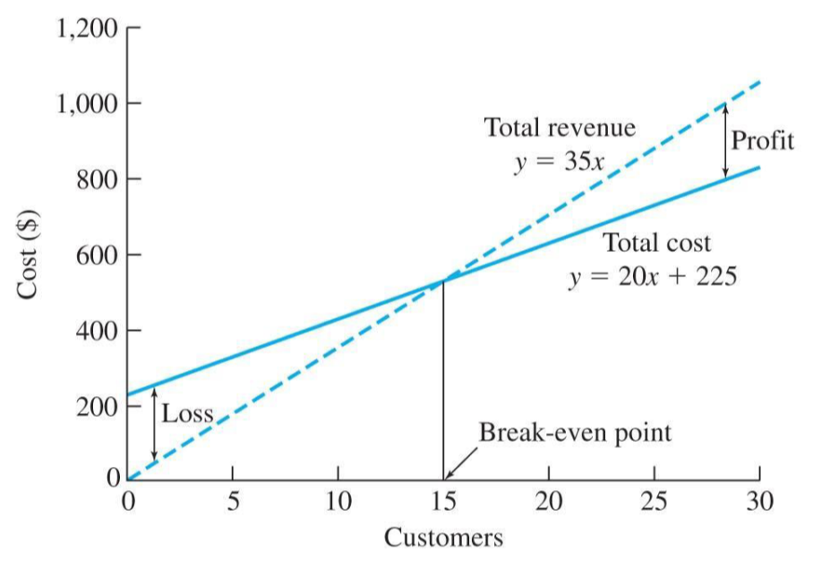

# Cost Estimation and Estimation Models

## Types of Cost Estimates

* Rough estimates: high-level estimates that vary in accuracy (-30% to +75%)
* Budget estimates: better accuracy than rough estimates (-15% to +20%)
* Detailed estimates: estimates made from detailed designs, using quantitative models and vendor quotes (-3% to +5%)
  + Per-Unit model: uses per-unit factor
  + Segmenting model: individual component estimates, added together
  + Cost Indexes model: uses historical change in costs as a ratio relationship
  + Triangulation model: uses different sources to arrive at estimate
  + Learning Curve model: percentage/rate at which output is increased, due to repetition
 $T_{N}=T_{initial}×N^{b}$

 $T_{N}$  - * = time required for Nth unit of production
      * $T_{initial}$ = time required for first unit of production
      * $N$ = number of completed units
      * $b$ = learning curve exponent = $\log_{2}{learning curve percentage}$
        + E.g. a curve with $b=-0.074$ is a 95% learning curve $$b=\log_{2}{0.95}=-0.074$$

Example: Joe is interested in a new home that is constructed with a certain type of material and has a specific construction style. Based on this information a contractor is quoting him a cost of $65 per square foot for his home. If Joe is interested in a 2000 square foot floor plan, estimate the cost of the house.

**Per-Unit model: $Cost=\$65×2000=\$130 000$**

Example: Calculate the time required to produce the hundredth unit of a production run if the first unit took 32.0 minutes to produce and the learning curve rate for production is 80%.

**Learning Curve model:**

$$b=\log_{2}{0.8}=-0.322$$

$$T_{N}=T_{initial}×N^{b} \\ T_{100}=32 mins×{100}^{-0.322} \\ =7.27 mins$$

Example: Estimate the overall labor cost portion due to a task that has a learning-curve rate of 85% and reaches a steady state value after 16 units of 5.0 minutes per unit. Labor and benefits are $22 per hour, and the task requires two skilled workers. The overall production run is 20 units.

$$b=\log_{2}{0.85}=-0.234$$

$$T_{16}=T_{initial}×{16}^{-0.234} \\ T_{initial}=\frac{5.0 mins}{{16}^{-0.234}}=9.6 mins$$

Then, calculate the amount of time required for each unit:

|  |  |  |  |  |  |
| --- | --- | --- | --- | --- | --- |
| **Unit** | **Time Required** | **Cumulative Time Required** | **Unit** | **Time Required** | **Cumulative Time Required** |
| 1 | 9.6 | 9.6 | 11 | 5.5 | 73.8 |
| 2 | 8.2 | 17.8 | 12 | 5.4 | 79.2 |
| 3 | 7.4 | 25.2 | 13 | 5.3 | 84.5 |
| 4 | 6.9 | 32.1 | 14 | 5.2 | 89.7 |
| 5 | 6.6 | 38.7 | 15 | 5.1 | 94.8 |
| 6 | 6.3 | 45 | 16 | 5.0 | 99.8 |
| 7 | 6.1 | 51.1 | 17 | 5.0 | 104.8 |
| 8 | 5.9 | 57.0 | 18 | 5.0 | 109.8 |
| 9 | 5.7 | 62.7 | 19 | 5.0 | 114.8 |
| 10 | 5.6 | 68.3 | 20 | 5.0 | 119.8 |

$$119.8 mins =2.0 hours→Labour costs=\$22×2×2=\$88$$

## Cost Indexes

Numerical values that reflect historical changes in engineering costs

$$\frac{Cost at time A}{Cost at time B}=\frac{Index at time A}{Index at time B}$$

Example: Miriam is interested in estimating the annual labour and material costs for a new production facility. Labour cost index value was at 124 ten years ago and is 188 today. Annual labor costs for a similar facility were $575,500 ten years ago. Material cost index value was at 544 three years ago and is 715 today. Annual material costs for a similar facility were $2,455,000 three years ago.

$$Labour cost today=\$575 500×\frac{188}{124}=\$872 532$$

$$Material cost today=\$2 455 000×\frac{715}{544}=\$3 226 700$$

# Cash Flow

* Cash flow diagrams represent income and expenses over some interval
  + Revenue = up arrow
  + Expense = down arrow
* Cash flows are assumed to occur at the end of each period

# Time Value of Money

* The relationship between interest and time – one unit of money received at a future date does not produce as much earnings as a unit of money received in the present

## Interest

* Lender’s point of view: interest rate is ratio between profit received and investment over a period of time (risk of loss, administrative costs, and pure profit)
* Borrower’s point of view: ratio between amount paid for use of funds and quantity of funds requested

### Simple Interest

Interest is only calculated on starting principle: $F=P\left(1+i×n\right)$

* $F$ = future amount
* $P$ = principle amount
* $i$ = interest rate
* $n$ = number of periods

Typically, consider year made up of 12 months, 30 days each = 360 days

Example: Find the simple interest on $4,500 at 8% per year for a) one year and b) 4 years.

$I=\$4,500×0.08=\$360$

$$F=\$4,500\left(1+0.08\right)=\$4,860$$

$I=\$4,500×0.08×4=\$1,440$

$$F=\$4,500\left(1+0.08×4\right)=\$5,940$$

Example: Find the simple interest on $1,000 for the period from 1 February to 20 April at 8% per year.

$$I=1000×0.08×\frac{30+30+20}{360}=\$17.78$$

### Compound Interest

Interest earned during each period is added to the principle: $F=P{\left(1+i\right)}^{n}$

Example: Find the simple interest on $1,000 at 8% per year for 4 years.

$$F=\$1,000{\left(1+0.08\right)}^{4}=\$1360.50$$

* **Cash expenditure and receipts diagrams** show the flow of the lender and borrower
* Default: annual interest rate with annual compounding
  + E.g. “12% interest” = 12% per year, compounded annually
  + E.g. “12% interest compounded monthly” = 12% per year, compounded monthly
    - Hence, interest is 1% per month
  + When the compounding period isn’t annual, problems must be solved in terms of the compounding period

Example: $100 is invested at 6% interest, compounded monthly. What is the future value of this investment after 4 years?

Interest = 6% per year, compounded monthly

$i=\frac{6\%}{12}=0.5\%$ per month

$n=4×12=48$ months

$$F=\$100{\left(1+0.005\right)}^{48}=\$127.05$$

### Nominal Interest Rate ($r$)

* The conventional method for stating the annual interest rate is $r$
* To find the corresponding interest rate for the subperiod, divide by the compounding period:
 $$i_{s}=\frac{r}{m}$$

 $i_{s}$ + = interest rate for subperiod
  + $r$ = nominal interest rate
  + $m$ = number of subperiods

### Effective Interest Rate

The actual interest rate, found by converting a given interest rate to an equivalent interest rate with a one-year compounding period

Given $F=P{\left(1+i_{s}\right)}^{m}$, find the effective interest rate $i_{c}$ that yields the same future amount $F$ at the end of the full period from the present amount $P$.

$$1+i_{c}={\left(1+i_{s}\right)}^{m} \\ i_{c}={\left(1+\frac{r}{m}\right)}^{m}-1$$

Example: What is the annual effective interest rate equivalent to a nominal rate of 12% a year compounded monthly?

$$r=12\% , m=12$$

$$i_{s}=\frac{0.12}{12}=0.01$$

$$i_{c}={\left(1+0.01\right)}^{12}-1=12.7\%$$

# Uniform and Gradient Series Cash Flows

## Equivalence

* In order to evaluate different investment alternatives, the sums of money produced at different times must be compared
* Two situations are equivalent when they have the same effect, worth, or value
* Three factors in equivalence:
  1. Amount of money
  2. Time of occurrence
  3. Rate of interest

## Cash Flow Patterns

1. Single disbursement
2. Annuity: set of equal disbursements over a sequence of periods
3. Arithmetic gradient series: set of disbursements that change by a constant amount from one period to the next
4. Geometric gradient series: set of disbursements that change by a constant proportion from one period to the next

## Compound Interest Factors

* Formulas that define mathematical equivalence for common cash flow patterns, allowing cash flow analysis to be done conveniently

### Compound Amount Factor $(F/P,i,N)$

The future amount $F$ that is equivalent to the present amount $P$, given an interest rate $i$ and number of periods $N$: $(F/P,i,N)={\left(1+i\right)}^{N}$

Example: How much money will be in a bank account at the end of 15 years if $100 is invested today and the nominal interest rate is 8% compound semi-annually?

$$r=8\%, m=2→i_{s}=\frac{0.08}{2}=0.04, n=15×2=30$$

$$F=P×(F/P,i,N)=\$100×{\left(1+0.04\right)}^{30}=\$324.34$$

### Present Worth Factor $(P/F, i,N)$

The present amount $P$ that is equivalent to the future amount $F$, given an interest rate $i$ and number of periods $N$: $(P/F,i,N)=\frac{1}{{\left(1+i\right)}^{N}}$

Example: How much should be invested now (at present time) at 8% compound interest per year, in order to receive $1,360.5 within 4 years; or what is the present equivalent worth of $1,360.5 to be received four years in the future?

$$P=F×(P/F,i,N)=\$1,360.50×\frac{1}{{\left(1+0.08\right)}^{4}}=\$1,000$$

Example: If you want to have $1,000,000 in your bank account when you are at age 65, how much you should invest at age of 20 if the bank interest rate is 12% (for the whole period of time)?

$$N=65-20=45$$

$$P=\$1,000,000×\frac{1}{{\left(1+0.12\right)}^{45}}=\$6098.02$$

### Sinking Fund Factor $(A/F, i,N)$

**Sinking fund**: interest-bearing account to which regular deposits are made in order to accumulate some amount

The size $A$ of a repeated disbursement that is equivalent to a future amount $F$, given an interest rate $i$ and number of periods $N$: $(A/F,i,N)=\frac{i}{{\left(1+i\right)}^{N}-1}$

Example: The Kelowna Club has decided to build a clubhouse and track five years from now. It must accumulate $50,000 by the end of five years by setting aside a uniform amount from its dues at the end of each year. If the interest rate is 10%, how much must be set aside each year?

$$A=F×(A/F,i,N)=\$50,000×\frac{0.10}{{\left(1+0.10\right)}^{5}-1}=\$8,189.87$$

### Uniform Series Compound Factor $(F/A, i,N)$

The future value $F$ that is equivalent to a series of equal-size receipts of disbursements of amount $A$, given an interest rate $i$ and number of periods $N$: $(F/A,i,N)=\frac{{\left(1+i\right)}^{N}-1}{i}$

Example: If you are to deposit in your bank account $100 yearly starting at the age 20, how much will your future fund be at age of 65 if the interest rate is kept constant at 12% for the whole period?

$$F=A×\left(F/A,i,N\right)=\$100×\frac{{\left(1+0.12\right)}^{45}-1}{0.12}=\$135,823$$

### Capital Recovery Factor $(A/P, i,N)$

The value of equal periodic payments of amount $A$ that are equivalent to a present amount P, given an interest rate $i$ and number of periods $N$: $(A/P,i,N)=\frac{i{\left(1+i\right)}^{N}}{{\left(1+i\right)}^{N}-1}$

### Series Present Worth Factor $(P/A, i,N)$

The present amount $P$ that is equivalent to an annuity with disbursement amount $A$, given an interest rate $i$ and number of periods $N$: $(P/A,i,N)=\frac{{\left(1+i\right)}^{N}-1}{i{\left(1+i\right)}^{N}}$

Example: Suppose that a recent college graduate has $3,000 available as a down payment on a new car. The graduate can afford a uniform car loan payment of no more than $500 per month for 48 months, beginning 1 month from now. Interest is 6%, compounded monthly. What is the most that the graduate can spend today on a new car?

$$i_{s}=\frac{0.06}{12}=0.005$$

$$P=A×\left(P/A,i,N\right)=\$500×\frac{{\left(1+0.005\right)}^{48}-1}{0.005{\left(1+0.005\right)}^{48}}=\$21,290$$

$$Max amount spent=P+\$3,000=\$21,290+\$3,000=\$24,290$$

## Formulas for Non-Uniform Payments

### Conversion Factor for Arithmetic Gradient Series

**Arithmetic gradient series**: start at 0 at end of first period, increase by constant amount each period

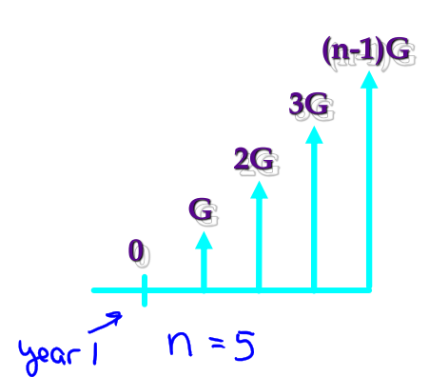

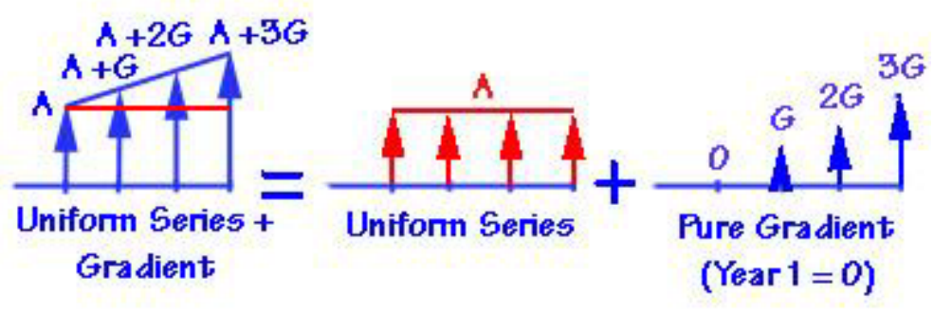

* Given a series of $n$ uniform-spaced payments that differ by a constant $G$ each period:
  + The future payment:
 $$F=\frac{G}{i}\left[\frac{{\left(1+i\right)}^{N}-1}{i}-N\right]$$

 + The single payment present worth:
 $$P=G\left[\frac{{\left(1+i\right)}^{N}-iN-1}{i^{2}{\left(1+i\right)}^{N}}\right]$$

 + The sinking fund payment:
$$A=G\left[\frac{{\left(1+i\right)}^{N}-iN-1}{i{\left(1+i\right)}^{N-1}}\right]$$

* Single payment present worth factor:
$$\left(P/G,i,N\right)=\left[\frac{{\left(1+i\right)}^{N}-iN-1}{i^{2}{\left(1+i\right)}^{N}}\right]$$

* Arithmetic gradient uniform series factor:

$$(A/G,i,N)=\left[\frac{{\left(1+i\right)}^{N}-iN-1}{i{\left(1+i\right)}^{N-1}}\right]$$

Example:

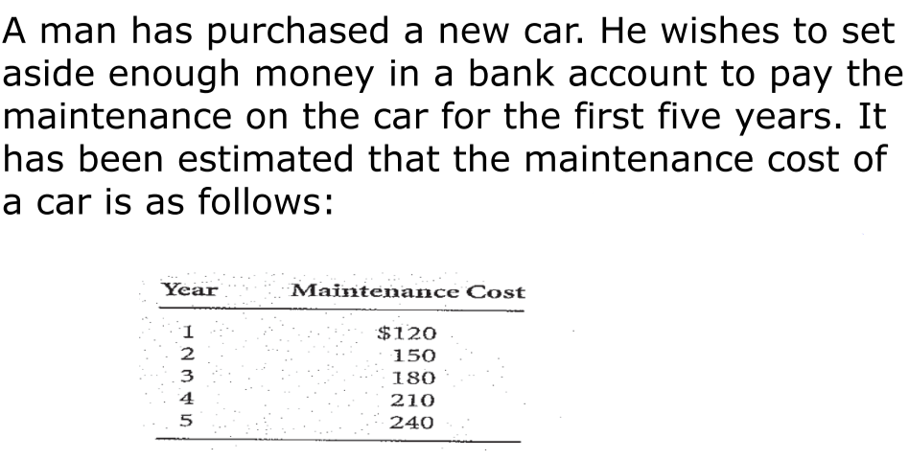

Assume maintenance costs occurs at the end of each year and that the bank pays 5% interest. How much should the car owner deposit in the bank now?

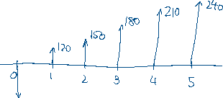

### Conversion Factor for Geometric Gradient Series

**Geometric gradient series**: start at 0 at end of first period, increase by constant percentage each period

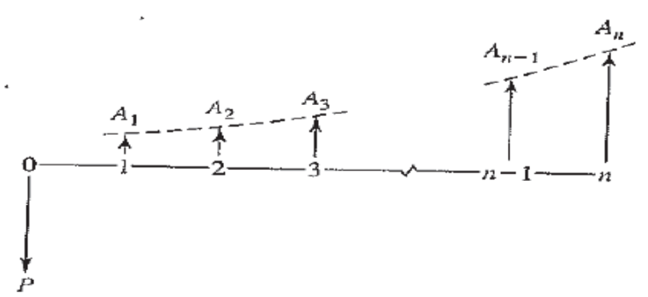

* Can model inflation/deflation, productivity improvement/degradation, or growth/shrinking of market size
* Geometric gradient present worth factor:
 $$\left(P/A,g,i,N\right)=\left[\frac{1-{\left(1+g\right)}^{N}{\left(1+i\right)}^{-N}}{i-g}\right]$$

 $g$ + = growth rate

Example: The first-year maintenance cost for a new car is estimated to be $100, and it increases at a uniform rate of 10% per year. Using an 8% interest rate, calculate the present worth of cost of the first five years of maintenance.

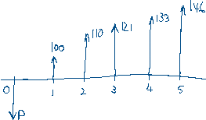

# Comparison Methods – Worth

## Introduction

* Two projects are **independent** if the expected costs/benefits of each project do not depend on whether the other one is chosen
* Two projects are **mutually exclusive** if, in the process of choosing one, all other alternatives are excluded
* Two projects are **related but not mutually exclusive** if the expected costs/benefits of one project depends on whether the other one is chosen

## Present Worth Analysis (PW)

* Used to determine the present value of future money disbursements
* If future income and costs are known, we can use a suitable interest rate to calculate the present worth of property, providing a good estimate of the price at which the property can be bought or sold

### Net Present Worth

$$NPW=PW of benefits-PW of costs$$

$$PW\left(i\right)=\sum_{k=0}^{N}{Z_{k}(P/F,i,k)}$$

* $Z_{k}$ is positive if period $k$ has net cash inflow, negative if period $k$ has net cash outflow
* $(P/F,i,k)$ is the present worth of future costs with interest $i$ for period $k$

Example:

* Wayne County will build an aqueduct to bring water in from the upper part of the state.
* It can be built at a reduced size now for $300 million and be enlarged 25 years hence for an additional $350 million.
* An alternative is to construct the full-sized aqueduct now for $400 million.
* Both alternatives would provide the needed capacity for the 50-year analysis period.
* Maintenance costs are small and may be ignored.
* At 6% interest, which alternative should be selected?

Two-stage construction:

$$PW of costs=\$300 million+\$350 million (P/F,0.06,25) \\ =\$300 million+\$350 million×\frac{1}{{\left(1+0.06\right)}^{25}} \\ =\$381.6 million$$

Single-stage construction:

$$PW of costs=\$400 million$$

Two-stage construction has smaller PW of costs, so is more desirable.

## Future Worth Analysis

* Net Future Worth: measures the surplus in an investment project at a time other than $t=0$
* Useful when you need to compute the equivalent worth of a project at the end of its investment period

$$FW\left(i\right)=\sum_{k=0}^{N}{Z_{k}(F/P or F/A,i,N-k)}$$

Example:

* Ron Jamison, a 20-year-old college student, consumes about a carton of cigarettes a week.
* He wonders how much money he could accumulate by age 65 if he quit smoking now and put his cigarette money into a savings account.
* Cigarettes cost $35 per carton.
* Ron expects that a savings account would earn 5% interest, compounded semi annually.
* Compute Ron’s future worth at age 65.

$$Cost of cigarettes per half year=\$35×26 weeks=\$910$$

$$i=\frac{0.05}{2}=0.025, N=45×2=90$$

$$FW=\$910×\left(F/A,0.025,90\right) \\ =\$910×\frac{{\left(1+0.025\right)}^{90}-1}{0.025} \\ =\$299,530$$

## Capitalized Cost Analysis

* Capitalized cost: the present sum of money that needs to be set aside now, at some interest rate, to yield the funds required to provide a service indefinitely
  + To accomplish this, the money set aside for future expenditures must not decline
  + The interest received on the money set aside can be spent, but not the principle

$$PW(i)=A\left(P/A,i,N→∞\right)=\frac{A}{i}$$

Because:

$$\left(P/A,i,N→∞\right)=\frac{1}{i}$$

Example: How much should one set aside to pay $50 per year for maintenance on a gravesite if interest is assumed to be 4%? For perpetual maintenance, the principal sum must remain undiminished after making the annual disbursement.

$$P=\frac{\$50}{0.04}=\$1250$$

Example: How much should a municipality set aside to pay $100,000 per year for maintenance on a highway if interest is assumed to be 5%? For perpetual maintenance, the principal sum must remain undiminished after making the annual disbursement.

$$P=\frac{\$100,000}{0.05}=\$2,000,000$$

## Annual Worth Analysis

* Converts money to an equivalent annual cost or benefit (e.g. convert present worth $P$ to an equivalent uniform end-of-period cash flows)
* Provides a basis for measuring the worth of an investment by determining equal payments on an annual basis

$$AW\left(i\right)=PW(i)(A/P,i,N)$$

Example: A student bought $1000 worth of home furniture. If it is expected to last 10 years, what will the equivalent uniform annual cost be if interest is 7%?



$$A=P\left(A/P,i,N\right) \\ =\$1000×\frac{0.07{\left(1+0.07\right)}^{10}}{{\left(1+0.07\right)}^{10}-1} \\ =\$142.37$$

### Capital Recovery Cost

* The annual equivalent of capitalized cost
$$CR\left(i\right)=P(i)\left(A/P,i,N\right)-S(i)(A/F,i,N)$$

* $P$ = initial cost
* $S$ = salvage value

### Payback Period

* Rough measurement of the time it takes for an investment to pay for itself

$$Payback period=\frac{First cost}{Annual savings}$$

Example:

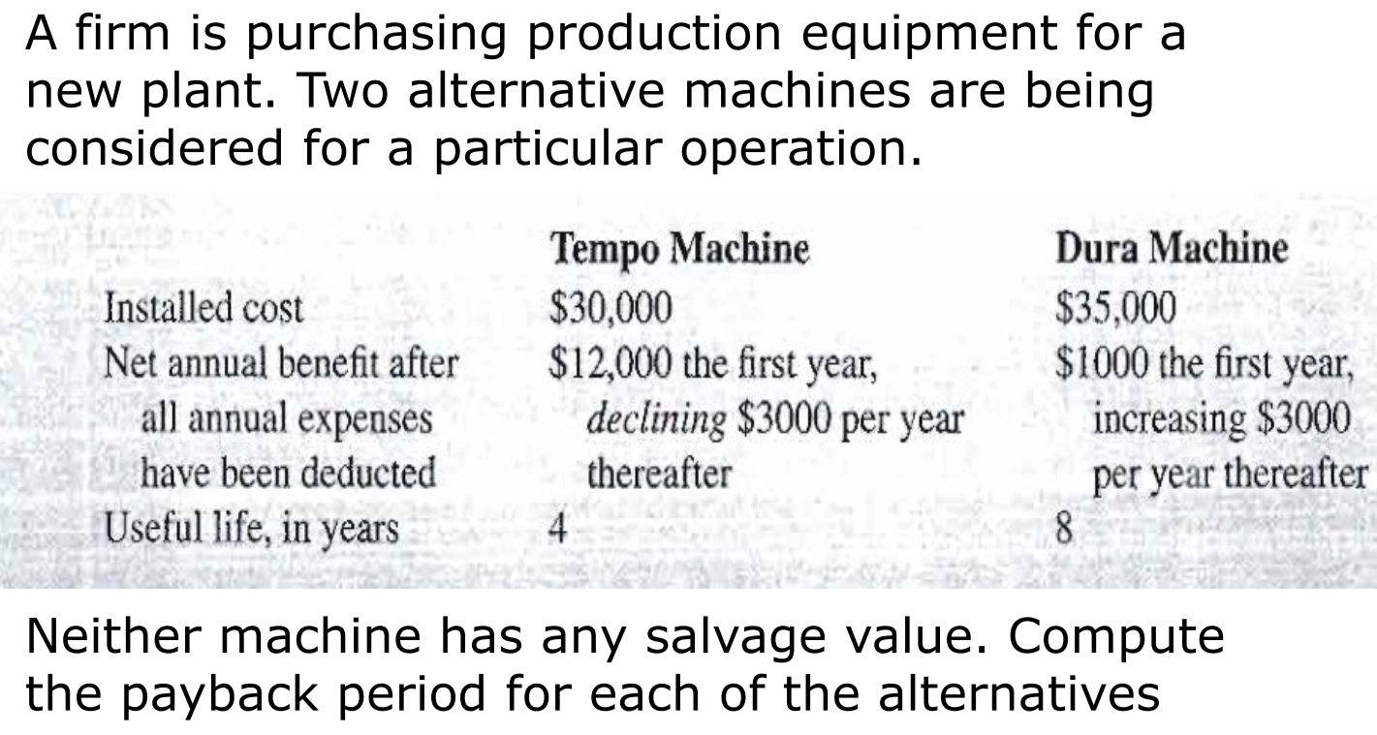

Tempo machine:

|  |  |  |  |  |
| --- | --- | --- | --- | --- |
| **Year** | 1 | 2 | 3 | 4 |
| **Annual savings** | $12,000 | $9,000 | $6,000 | $3,000 |
| **Cumulative savings** | $12,000 | $21,000 | $27,000 | $30,000 |

$$Payback period=4 years$$

Dura machine:

|  |  |  |  |  |  |
| --- | --- | --- | --- | --- | --- |
| **Year** | 1 | 2 | 3 | 4 | 5 |
| **Annual savings** | $1,000 | $4,000 | $7,000 | $10,000 | $13,000 |
| **Cumulative savings** | $1,000 | $5,000 | $12,000 | $22,000 | $35,000 |

$$Payback period=5 years$$

### PV Installation Example Project

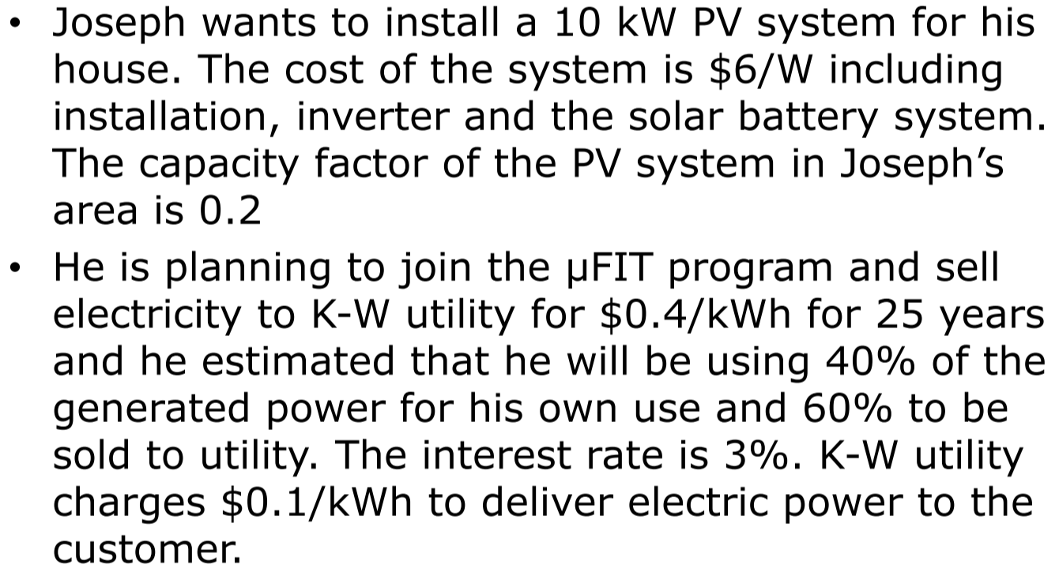

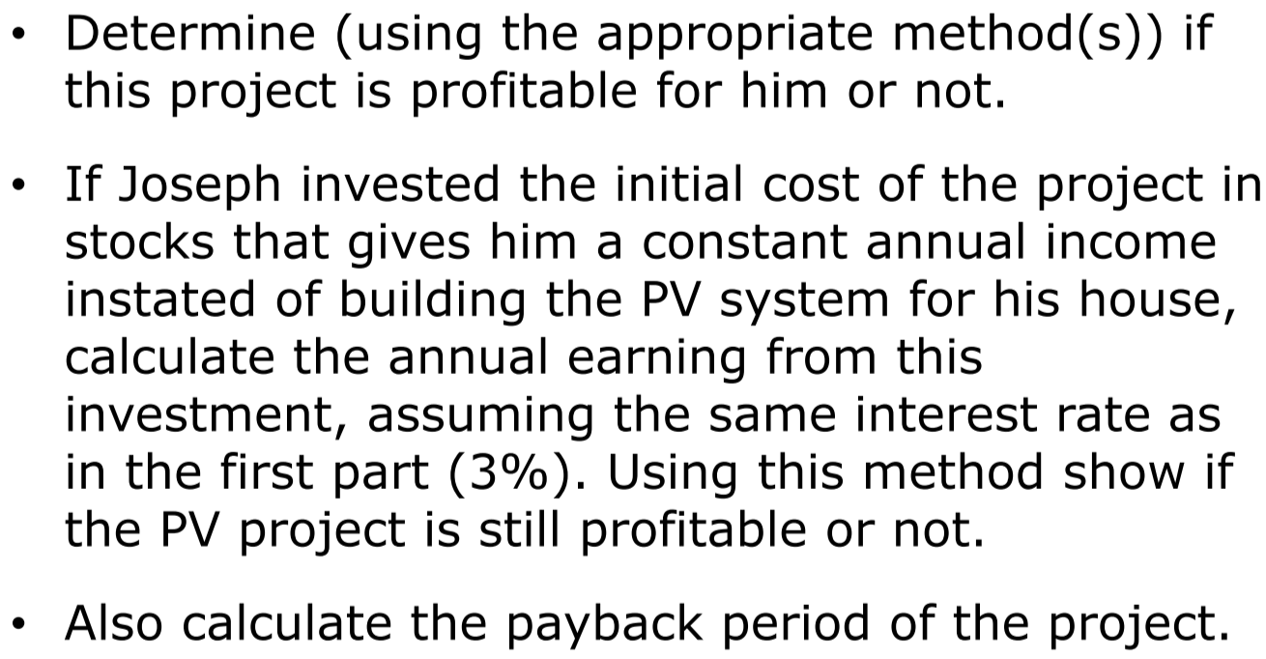

Part 1:

$$Present cost P=10,000 W×\$6/W=\$60,000$$

$$Amount of energy produced by solar PV=10 KW×0.2×8760 h/year=17,520 KWh$$

$$Revenue received from utility=17,520 KWh×0.6×\$0.4/KWh=\$4205/year$$

$$Revenue due to saving electricity bill=17,520 KWh×0.4×\$0.1/KWh=\$700/year$$

$$A=\$4,205+\$700=\$4,905/year$$

$$P=A\left(P/A,i,N\right) \\ =\$4,905×\frac{{\left(1+0.03\right)}^{25}-1}{0.03{\left(1+0.03\right)}^{25}} \\ =\$85,411$$

$$NPW=PW of benefits-PW of costs=\$85,411-\$60,000=\$25,411$$

Since $NPW$ is positive, the project is profitable.

Part 2:

$$A=P\left(A/P,i,N\right) \\ =\$60,000×\frac{0.03{\left(1+0.03\right)}^{25}}{{\left(1+0.03\right)}^{25}-1} \\ =\$3,445.67$$

It is more profitable to undertake the PV project.

Part 3:

$$Payback period=\frac{\$60,000}{\$4,905}=12.23 years$$

# Rates of Return

## Internal Rate of Return (IRR)

* Most frequently used exact analysis technique
* No interest rate is required for calculations, unlike present worth and annual cash flow
* Rate of return is computed from cash flow
* To decide whether IRR is good, compare with predetermined **Minimum Acceptable Rate of Return (MARR)**
* Internal Rate of Return (IRR): the interest rate $i^{*}$ such that, when all the project’s cash flows are discounted at $i^{*}$, the present worth of the cash inflows = the present worth of the cash outflows – the project breaks even
  + Negative IRR means the project is losing money
  + Usually solve equations for IRR by trial and error
$$\sum_{t=0}^{T}{\frac{R_{t}-D_{t}}{1+i^{*}}}=0$$

* $R_{t}$ = cash inflows in period $t$
* $D_{t}$ = cash outflows in period $t$
* $T$ = the number of time periods
* $i^{*}$ = the internal rate of return

In order to calculate IRR, disbursements and receipts must be comparable – as present worth, uniform series, or future worth

$PW\left(disbursements\right)=PW\left(receipts\right)$

$AW\left(disbursements\right)=AW\left(receipts\right)$

$FW\left(disbursements\right)=FW(receipts)$

## Incremental Rate of Return (ΔIRR)

* Incremental Rate of Return (ΔIRR): when there are two alternatives, used to calculate the difference between alternatives
  + Calculate the cash flow for the difference between alternatives by taking higher initial-cost alternative minus lower initial-cost alternative
    - If ΔIRR >= MARR, choose the higher initial-cost alternative
    - Else, choose lower initial-cost alternative
* Related definitions:
  + Equivalent Uniform Annual Cost (EUAC)
  + Equivalent Uniform Annual Benefit (EUAB)
  + EUAC – EUAB = difference term

Example: An $8200 investment returned $2000 per year over a 5-year useful life. What was the rate of return on the investment?

$$PW\left(costs\right)=\$8200$$

$$PW\left(benefits\right)=\$2000×(P/A,i,5)$$

$$\frac{PW\left(costs\right)}{PW(benefits)}=1 \\ \$8200=\$2000×(P/A,i,5) \\ (P/A,i,5)=\frac{\$8200}{\$2000} \\ =4.1$$

Looking at the table, $i=7\%$ for $(P/A,i,5)=4.1$

Example: Calculate the rate of return for the following cash flow:

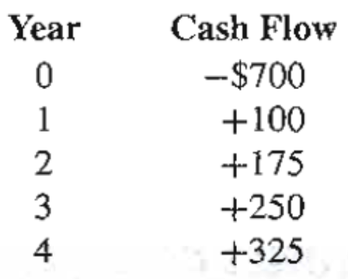

$$EUAC=\$700×(A/P,i,4)$$

$$P_{A-B}=\$100$$

$$P_{G-B}=\$75×(A/G,i,4)$$

$$EUAB=\$100+\$75×(A/G,i,4)$$

Use trial and error to determine at what interest rate $EUAC-EUAB=0$

Example:



Tempo Machine:

Alternative rate of return = 0%, since sum of cash flows = 0

Dura Machine:

$$\$35,000=\$1000(P/A,i,8)+\$3000(P/G,i,8)$$

Using trial and error, alternative rate of return is ~19%.

Example: Calculate the rate of return for the following cash flow:

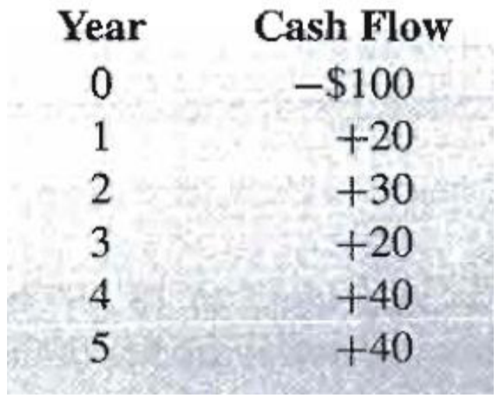

$$NPW=PW of benefits-PW of costs$$

$$PW of costs=\$100$$

$$PW of benefits=\$20×\left(P/F,i,1\right)+\$30×\left(P/F,i,2\right)+\$20×\left(P/F,i,3\right)+\$40×\left(P/F,i,4\right)+\$40×\left(P/F,i,5\right)$$

Using trial and error, $NPW=10.16$ when $i=10\%$ and $NPW=-4.02$ when $i=15\%$

$$y=mx+b$$

$$m=\frac{-4.02-10.16}{15\%-10\%}=-2.836$$

$$b=y-mx \\ =10.16-\left(-2.836\right)\left(10\%\right) \\ =38.52$$

$$0=-2.836i+38.52 \\ i=-\frac{38.52}{-2.836}=13.58\%$$

$$i=10\%+10.16×\frac{5\%}{10.16+4.02}=13.58\%$$

### NPW Plots for Typical Investments

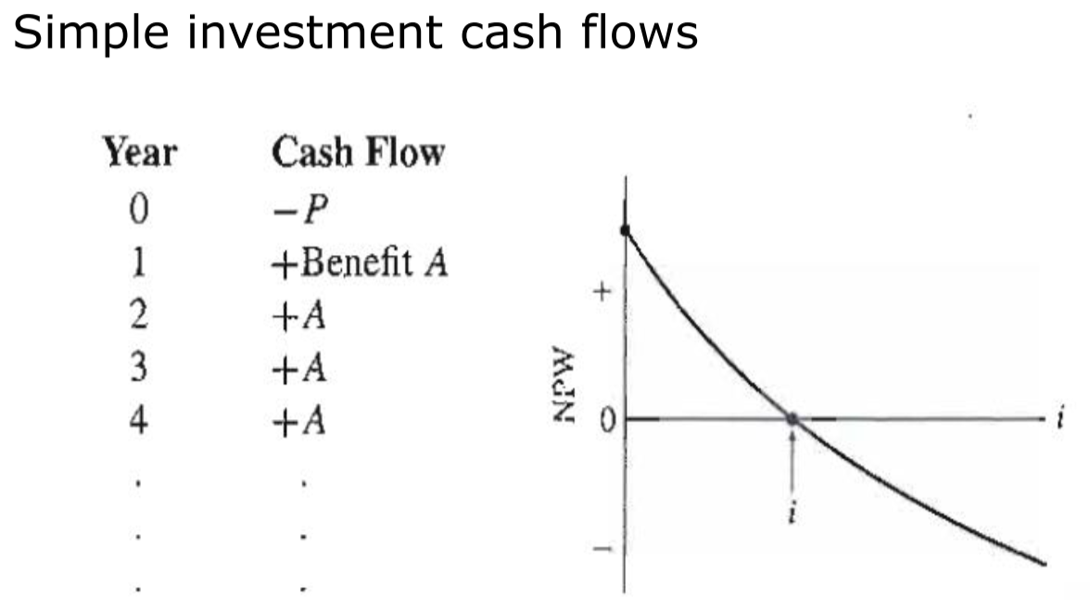

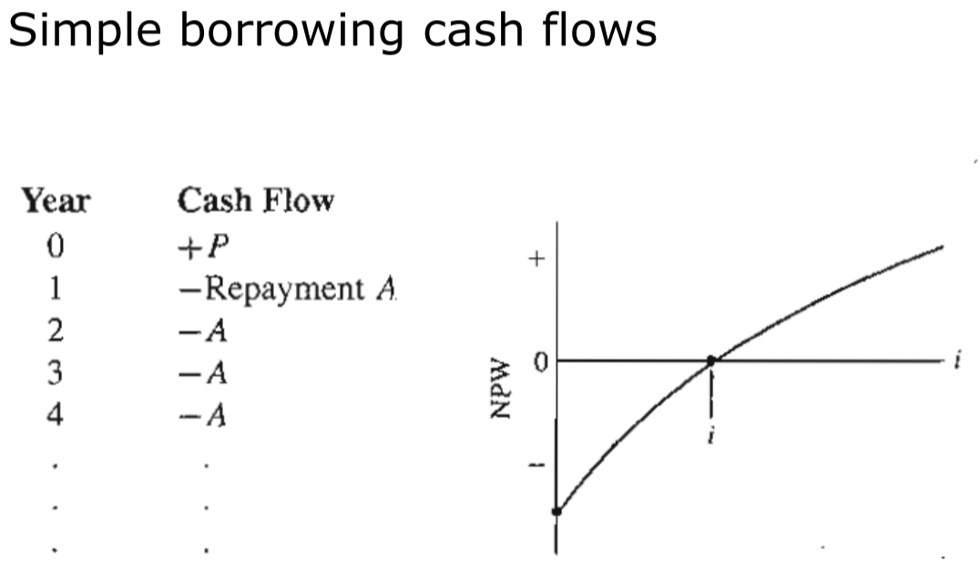

### PV Installation Example Project

$$IRR=\frac{PW of benefits}{PW of cost}=\frac{\$4,905×(P/A,i,25)}{\$60,000}=1$$

$$(P/A,i,25)=\frac{\$60,000}{\$4,905}=12.23$$

From the table:

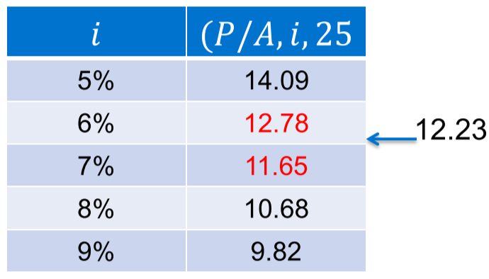

Hence, $i=6\%+\left(12.78-12.23\right)×\frac{1\%}{12.78-11.65}=6.487\%$

Example:

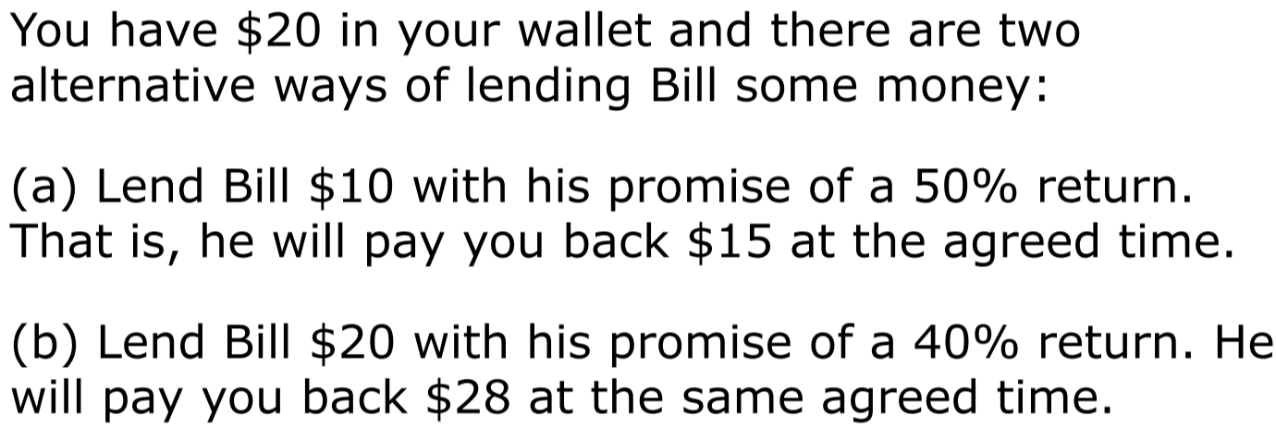

Assume MARR = 6%.

|  |  |  |  |
| --- | --- | --- | --- |
| Year | Alt. 1 | Alt. 2 | Alt. 1 – Alt. 2 |
| 0 | $$-10$$ | $$-20$$ | $$10-(-20)=+10$$ |
| 1 |  |  |  |

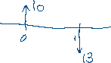

The cash flow of the difference represents a **loan** (as if we borrowed $10 in year 0 and repaid $13 in year 1). Hence, 30% is the **interest rate paid** to borrow the money.

Since the MARR is 6%, this means (Alt. 1 – Alt. 2) is undesirable. Hence, Alternative 2 is the better option.

### Comparing Investments vs. Borrowing

* When looking at **increments of investment** (pay first, gain later), accept the increment (Alt. 1) when $∆IRR≥MARR$
* When looking at **increments of borrowing** (gain first, pay later), accept the increment (Alt. 1) when $∆IRR≤MARR$

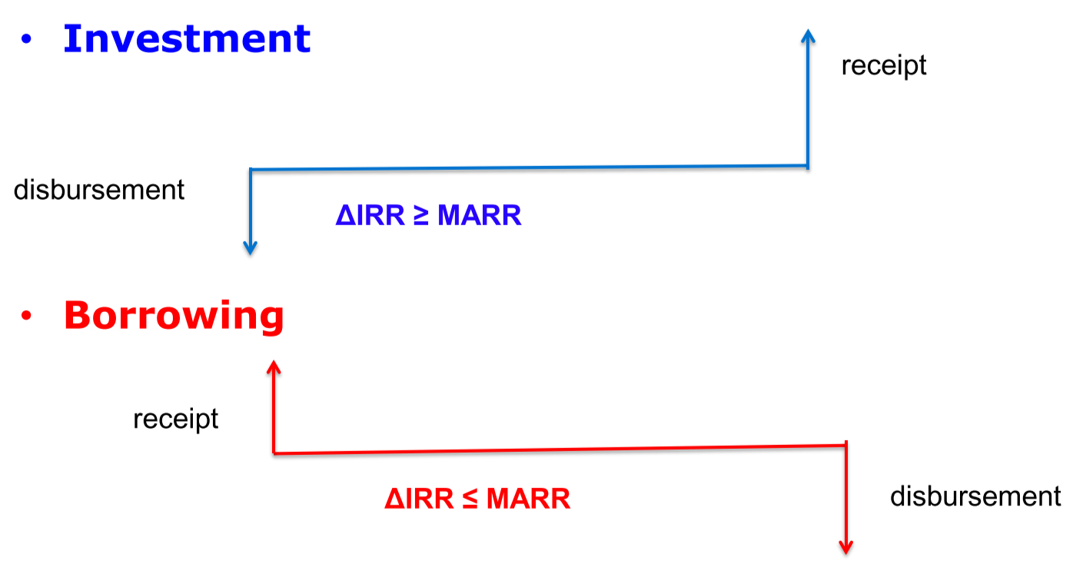

## Non-Simple Investment with Multiple Rate of Return

* This occurs when there are two or more sign changes in cash flow
* When this occurs, the equation to find the internal rate of return is:
 $$PW=0=-CF_{0}+CF_{1}{\left(1+i\right)}^{-1}+CF_{2}{\left(1+i\right)}^{-2}+…+CF_{n}{\left(1+i\right)}^{-n}$$

 $CF_{k}$ + is the cash flow for period $k$
* Letting $X_{i}={\left(1+i\right)}^{-i}$:
$$PW=0=CF_{0}+CF_{1}X_{1}+…+CX_{n}$$

* The equation is an nth-order polynomial
* Descartes’ rule describes the number of positive roots: If a polynomial with real coefficients has $m$ sign changes, the number of positive roots will be $m-2k$, where $k$ is an integer between $0$ and $\frac{m}{2}$.

Example:

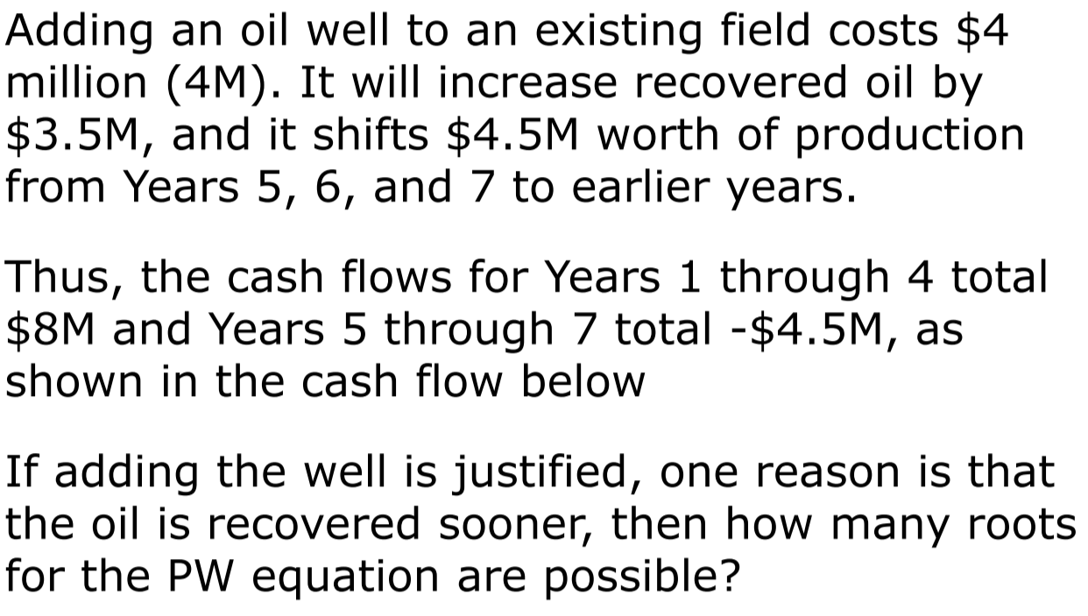

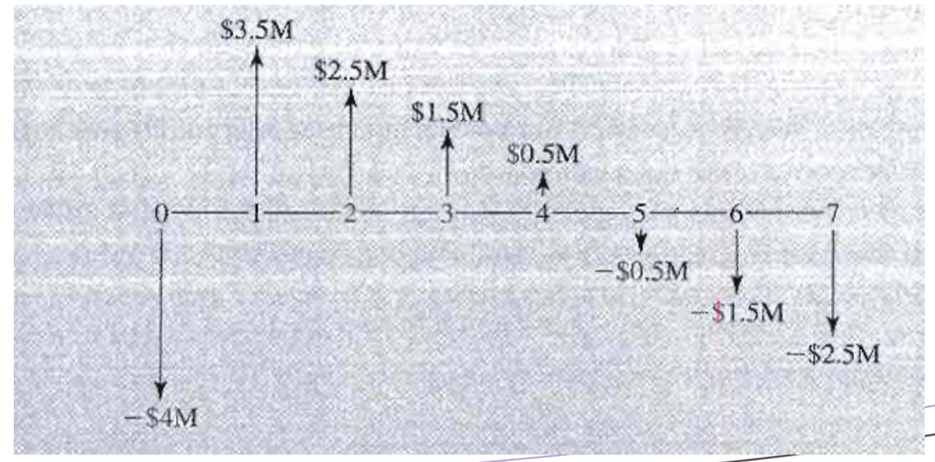

The number of positive roots is $m-2k$, where $k$ is between $0$ and $\frac{m}{2}$.

In this case, there are 2 sign changes, so $m=2$.

Then $k$ is between 0 and 1, so there are 0 or 2 positive roots.

## External Rate of Return (ERR)

The external rate of return $i_{e}^{*}$ is the rate of return on a project where any cash flows not invested in the project are assumed to earn interest at a predetermined explicit rate (usually the MARR)

* ERR can also be defined as the rate at which the organization usually invests ($e_{inv}$) or borrows/finances ($e_{fin}$)
* Because profitable terms invest at higher rates than they borrow at, the rate for investing is usually higher than the rate for financing
* Computing precise ERR is complex, so we can approximate

### Approximate External Rate of Return ($i_{ea}^{*}$)

1. Take all net receipts forward at the MARR to the time of the last cash flow
2. Take all net disbursements forward at unknown interest rate $i_{ea}^{*}$, also to the time of the last cash flow
3. Equate the future value of receipts from step 1 and disbursements from step 2, and solve for $i_{ea}^{*}$

$$\sum_{k=0}^{N}{E_{k}(F/P,i_{ea}^{*},N-k)}=\sum_{k=0}^{N}{R_{k}(F/P,MARR,N-k)}$$

* $E_{k}$ = disbursements in year $k$
* $R_{k}$ = receipts in year $k$

### Modified Internal Rate of Return (MIRR)

1. Combine cash flows in each period to a single net receipt $R_{k}$ or net expense $E_{k}$
2. Find the **present worth** of the expenses with the **financing rate $e_{fin}$**
3. Find the **future worth** of the receipts with the **investing rate $e_{inv}$**
4. Find the MIRR that makes the present and future worth equivalent

$$(F/P,MIRR,N)\sum_{k=0}^{N}{E_{k}(F/P,e_{fin},N-k)}=\sum_{k=0}^{N}{R_{k}(F/P,e_{inv},N-k)}$$

* This equation will have a unique root, since it has a single negative present worth and a single positive future worth

Example: Adding an oil well to an existing field had the cash flows summarized in the figure below Figure. If the firm normally borrows money at 8% and invests at 15%, find the modified internal rate of return (MIRR).





Present worth of expenses, using $e_{fin}$:

$$PW=-\$4M-\$0.5M\left(F/P,0.08,5\right)-\$1.5M\left(F/P,0.08,6\right)-\$2.5M\left(F/P,0.08,7\right) \\ =-\$4M-\$0.5M×\frac{1}{{\left(1+0.08\right)}^{5}}-\$1.5M×\frac{1}{{\left(1+0.08\right)}^{6}}-\$2.5M×\frac{1}{{\left(1+0.08\right)}^{7}} \\ =-\$6,744,272.03$$

Future worth of receipts, using $e_{inv}$:

$$FW=\$3.5M\left(P/F,0.15,6\right)+\$2.5M(P/F,0.15,5)+\$1.5M(P/F,0.15,4)+\$0.5M(P/F,0.15,3) \\ =\$3.5M{\left(1+0.15\right)}^{6}+\$2.5M{\left(1+0.15\right)}^{5}+\$1.5M{\left(1+0.15\right)}^{4}+\$0.5M{\left(1+0.15\right)}^{3} \\ =\$16,508,052.50$$

$$\left(F/P,MIRR,7\right)\left(-\$6,744,272.03\right)=\$16,508,052.50 \\ {\left(1+MIRR\right)}^{7}=\frac{\$16,508,052.50}{-\$6,744,272.03} \\ MIRR=0.1364=13.64$$

# Comparison Methods Between Projects

## Present Worth (PW) Comparisons

* Compute the present worth of the two projects at the MARR – preferred project is the one with the higher PW
* **For independent projects**:
  + Alternative to investing money in a project is to do nothing
  + The PW of any money saved doing nothing is 0, hence:
    - If an independent project has a **PW > 0**, it is acceptable
    - If **PW = 0**, it is marginally acceptable
    - If **PW < 0**, it is unacceptable

Example:

Steve Chen, a third-year electrical engineering student, has noticed that the networked personal computers provided by his university for its students are frequently fully utilized, so that students often have to wait to get on a machine. Steve sees the opportunity to create an alternative network in a mall near the campus.

The first cost for equipment, furniture, and software is expected to be $70,000.

Students would be able to rent time on computers by the hour and to use the printers at a charge per page.

Annual net cash flow from computer rentals and other charges, after paying for labour, supplies, and other costs, is expected to be $30,000 a year for five years.

When the university opens new facilities at the end of five years, business at Steve's network would fall off and net cash flow would turn negative.

Therefore, the plan is to dismantle the network after five years.

The five-year-old equipment and furniture are expected to have zero value.

If investors in this type of service enterprise demand a return of 20% per year, is this a good investment?

$$PW=-\$70,000+\$30,000(P/A,20\%,5) \\ =-\$70,000+\$30,000×\frac{{\left(1+0.2\right)}^{5}-1}{0.2{\left(1+0.2\right)}^{5}} \\ =\$19,718.36$$

Since $PW>0$, it is a good investment.

Example:

* A mechanical engineer is considering building automated materials-handling equipment for a production line.
* On the one hand, the equipment would substantially reduce the manual labour currently required to move items from one part of the production process to the next.
* On the other hand, the equipment would consume energy, require insurance, and need periodic maintenance.

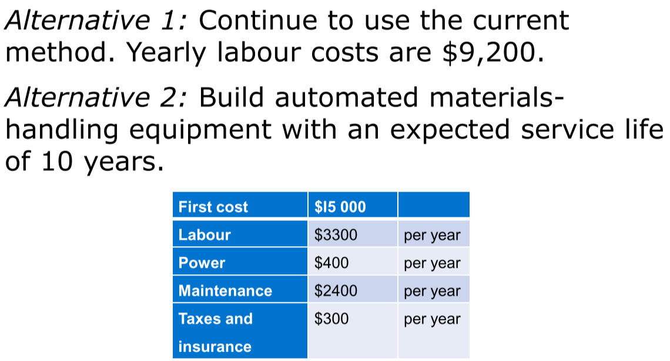

* If the MARR is 9%, which alternative is better? Use a present worth comparison.

By spending $15,000, you save $9,200 – $6,400 per year:

$$PW=-\$15,000+(\$9,200-\$6,400)(P/A,9\%,10)$$

$$=-\$15,000+\$2,800×\frac{{\left(1+0.09\right)}^{10}-1}{0.09{\left(1+0.09\right)}^{10}} \\ =\$2,969.44$$

Since $PW>0$, should choose Alternative 2.

## Annual Worth (AW) Comparisons

* Same as PW comparisons, but transform all disbursements and receipts into a uniform series at the MARR
* Any present worth can be converted into annuity using $(A/P,i,N)$
* Comparing two projects with the same lifespan using present worth and annual worth will always return the same preferred project

Example:

* Sweat University is considering two alternative types of bleachers for a new athletic stadium.
* Alternative 1: Concrete bleachers. The first cost is $350,000. The expected life of the concrete bleachers is 90 years and the annual upkeep costs are $2500.
* Alternative 2: Wooden bleachers on earth fill. The first cost of $200,000 consists of $100,000 for earth fill and $100,000 for the wooden bleachers. The annual painting costs are $5000. The wooden bleachers must be replaced every 30 years at a cost of $100,000.
* The earth fill will last the entire 90 years.
* Therefore, the greatest net benefit is obtained by choosing the alternative with the lower cost.
* The university uses a MARR of 7%. Which of the two alternatives is better?

Alternative 1:

$$AW=\$350,000×\left(A/P,7\%,90\right)+\$2,500 \\ =\$350,000×\frac{0.07{\left(1+0.07\right)}^{90}}{{\left(1+0.07\right)}^{90}-1}+\$2,500 \\ =\$27,055.67$$

Alternative 2:

$$AW=\$100,000×\left(A/P,7\%,90\right)+\$5,000+\$100,000×\left(A/P,7\%,30\right) \\ =\$100,000×\frac{0.07{\left(1+0.07\right)}^{90}}{{\left(1+0.07\right)}^{90}-1}+\$5,000+\$100,000×\frac{0.07{\left(1+0.07\right)}^{30}}{{\left(1+0.07\right)}^{30}-1} \\ =\$20,075$$

Alternative 2 has lower annual cost, so Alternative 2 is better.

## Comparing Alternatives with Unequal Lifespans

1. **Repeat the service life** to arrive at a common service period for all alternatives, and assume that each alternative can be repeated with the same costs and benefits in the future
2. Adopt a **specific study period** – in this case, need to assume salvage value whenever the lifespan of an alternative is longer than the study period

Example:

A mechanical engineer has decided to introduce automated materials-handling equipment for a production line. She must choose between two alternatives: building the equipment or buying the equipment off the shelf. Each alternative has a different service life and a different set of costs. If the MARR is 9%, which alternative is better?

Alternative 1: Build custom automated materials-handling equipment.

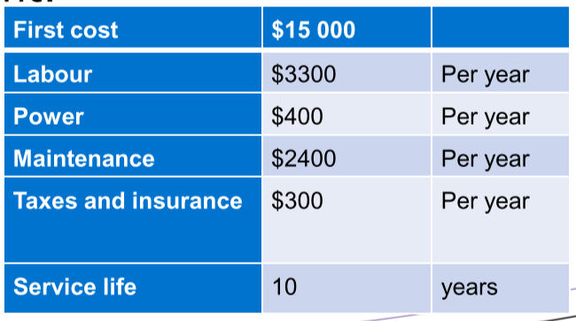

Alternative 2: Buy off-the-shelf standard automated materials-handling equipment.

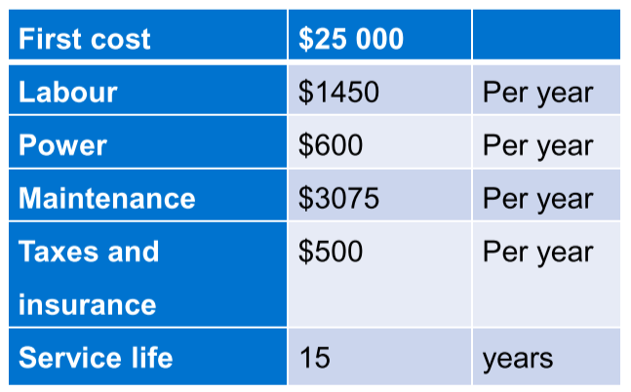

**Repeated lives method**: LCM of service lives: 30 years

Alternative 1 is repeated 3 times:

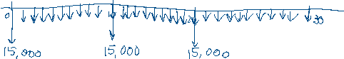

Alternative 2 is repeated 2 times*:*

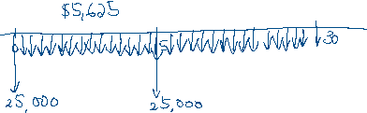

Using this method, Alternative 2 has the lower cost and is the better alternative.

**Period of study method**: study period of 10 years, assume salvage value of Alternative 2 is $5,000

Alternative 1:

$$PW=-\$15,000-(\$3,300+\$400+\$2400+\$300)(P/A,9\%,10) \\ =-\$15,000-\$6,400×\frac{{\left(1+0.09\right)}^{10}-1}{0.09{\left(1+0.09\right)}^{10}} \\ =-\$56,073.01$$

Alternative 2:

$$PW=-\$25,000-(\$1,450+\$600+\$3,075+\$500)(P/A,9\%,10)+\$5,000×(P/F,9\%,10) \\ =-\$25,000-\$5,625×\frac{{\left(1+0.09\right)}^{10}-1}{0.09{\left(1+0.09\right)}^{10}}+\$5,000×\frac{1}{{\left(1+0.09\right)}^{10}} \\ =-\$58,987.27$$

Using this method, Alternative 1 has lower costs and is the better alternative.

## Future Worth (FW) Analysis

* FW analysis deals with what the future situation will be, if we take some course of action now

Example:

* An east coast firm has decided to establish a second plant in Kansas City.
* There is a factory for sale for $850,000 that, with extensive remodeling, could be used.
* As an alternative, the company could buy vacant land for $85,000 and have a new plant constructed there.
* Either way, it will be 3 years before the company will be able to get a plant into production.
* The timing and cost of the various components for the factory are given in the following cash flow table:

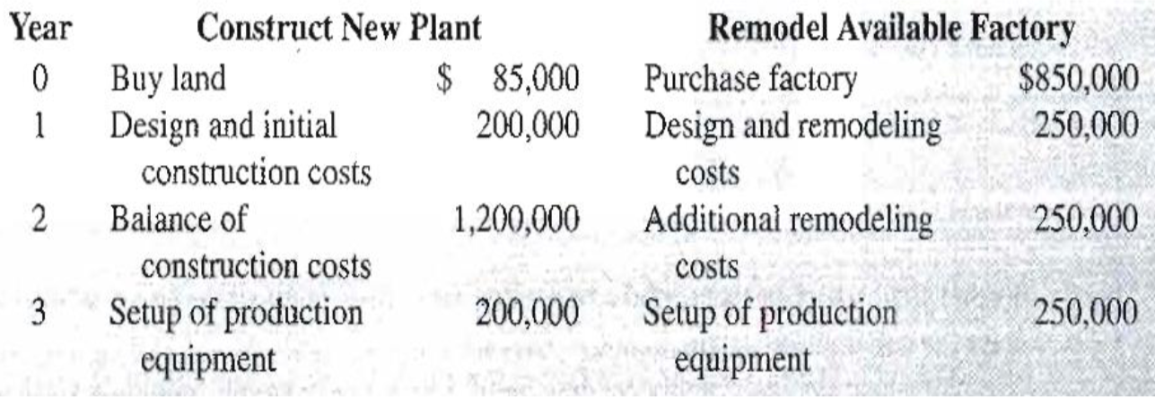

* If interest is 8% (MARR), which alternative results in the lower equivalent cost when the firm begins production at the end of the third year?

Construct New Plant:

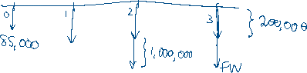

OR

$$FW=\$85,000×\left(F/P,8\%,3\right)+\$200,000×\left(F/A,8\%, 3\right)+\$1,000,000×\left(F/P,8\%,1\right) \\ =\$85,000×{\left(1+0.08\right)}^{3}+\$200,000×\frac{{\left(1+0.08\right)}^{3}-1}{0.08}+\$1,000,000×{\left(1+0.08\right)}^{1} \\ =\$1,836,355.52$$

Remodel Available Factory:

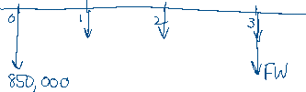

Since constructing the new plant has lower FW of costs, it is the better option.

## Payback Period

$$Payback period=\frac{First cost}{Annual savings}$$

* Easiest way of judging the economic viability of project is estimating how much time the investment will pay for itself
* Payback period is the number of years it takes an investment to be recoupled when the interest rate is assumed to be 0
* Disadvantages:
  + Discriminates against long-term projects
  + Ignores the effect of timing of cash flows within the payback period
  + Disregards interest rates
  + Ignores expected service life and/or the benefits that accrue after the end of the payback period

# Equivalence of Different Methods

## Equivalence of Rate of Return and Present/Annual Worth Methods

* If an independent project has a unique IRR, the IRR method and present worth method will give the same decision
* We already noted that the present worth and annual worth methods give the equivalent decision
* By extension, the ROR method and the annual worth method also give equivalent decisions
  + Since ROR is a relative measurement, it ignores the scale of the investment; thus, it must be applied on the increment between the two alternatives

Example:

* A tourist-area resort is considering adding either a parasailing operation or kayak rentals to their other activities. Available space limits them to one of these two choices.
* The initial costs for parasailing will be $100,000 with net returns of $15,000 annually for the 15-
* year life of the project.
* Initial costs for kayaking will be $10,000 with net returns of $2,000 per year for its 15-year life.
* Assume that both projects have a $0 salvage value after 15 years, and the MARR is 10%.

1. Using present worth analysis, which alternative is better?
2. Using IRR, which alternative is better?

Parasailing PW Analysis:

$$PW=-\$100,000+\$15,000(P/A,10\%,15) \\ =-\$100,000+\$15,000×\frac{{\left(1+0.10\right)}^{15}-1}{0.10{\left(1+0.10\right)}^{15}} \\ =\$14,091.19$$

Kayaking PW Analysis:

$$PW=-\$10,000+\$2,000(P/A,10\%,15) \\ =-\$10,000+\$2,000×\frac{{\left(1+0.10\right)}^{15}-1}{0.10{\left(1+0.10\right)}^{15}} \\ =\$5,212.16$$

Parasailing yields the higher present worth, so it is the better option.

IRR Analysis – need to check increment:

$$IRR=\frac{PW of benefits}{PW of costs}=\frac{(\$15,000-\$2,000)(P/A,i,15)}{(\$100,000-\$10,000)}=1$$

$$\left(P/A,i,15\right)=\frac{\$100,000-\$10,000}{\$15,000-\$2,000}=6.92$$

From the table, $i_{para-kayak}^{*}=11.7\%$

Since the increment exceeds the MARR of 10%, the first alternative – parasailing – is the better option.

### Comparing ROR of Mutually Exclusive Projects

* To compare mutually exclusive projects, write the cash flow of project B as: $$B=A+(B-A)$$ 
  + $A$ = same cash flow as project A
  + $B-A$ = increment component
* The only situation in which B is preferred to A is when the rate of return of the increment component exceeds the MARR

# Cost Benefit Ratio, Sensitivity, and Breakeven Methods

## Cost Benefit Ratio Method

* Previously, economic relationships were written like: $$PW of costs=PW of benefits \\ EUAC=EUAB$$
* Instead of writing them like that, we can write them as: $$\frac{PW of benefits}{PW of costs}=1 \\ \frac{EUAB}{EUAC}=1$$ 
  + Given a MARR, we consider an alternative acceptable if the benefit-cost ratio >= 1: $$\frac{PW of benefits}{PW of costs}=\frac{EUAB}{EUAC}≥1$$

Example:

* A firm is trying to decide which of two devices to install to reduce costs in a particular situation.
* Both devices cost $1000 and have useful lives of 5 years and no salvage value.
* Device A can be expected to result in $300 savings annually.
* Device B will provide cost savings of $400 the first year, but savings will decline by $50 annually, making the second-year savings $350, the third-year savings $300, and so forth.

With interest at 7%, which device should the firm purchase?

Device A:

$$\frac{B}{C}=\frac{\$300\left(P/A,7\%,5\right)}{\$1,000}$$

$$\frac{B}{C}=\frac{\$300×4.1}{\$1,000}=1.23$$

Device B:

$$\frac{B}{C}=\frac{\$400\left(P/A,7\%,5\right)-\$50\left(P/G,7\%,5\right)}{\$1,000}$$

$$\frac{B}{C}=\frac{\$400×4.1-\$50×7.647}{\$1,000}=1.258$$

Device B has a higher benefit-cost ratio, so it is the better purchase.

### Benefit-Cost and Private vs. Public Sector Projects

* **Private sector**:
  + Firm pays all costs and receives all benefits
  + Evaluating the merits of an investment involves technical feasibility, comparison at MARR, and engineering studies
  + Estimated benefits and costs are compared at PW, using a pre-determined discount rate
* **Public sector**:
  + Revenue generated through taxes and should be spent in public interest
  + Government pays cost but receives little benefit
  + Projects do not have “profits”

### Disbenefits

* Disbenefits are values that are subtracted from benefits or added to costs
* Either approach works, as long as you stay consistent

### B/C Ratios

* If B/C > 1, accept the project
* If B/C < 1, reject the project
* If B/C close to 1, look at other intangible factors

**Traditional:**

$$\frac{B}{C}=\frac{Benefits-Disbenefits}{Costs}$$

**Modified:**

$$\frac{B}{C}=\frac{Benefits-Disbenefits-O\&M costs}{Costs}$$

* No difference in accept/reject returned, only the magnitude of the ratio

Example:

* Ford Foundation expects to award $15 million in grants to public high schools to develop new ways to teach fundamentals of engineering to prepare students for university level.
* The grant will extend over a 10-year period and create an estimated savings of $1.5 million/year in faculty salaries and student related expenses.
* The Foundations uses a ROR of 6%/year on all grant awards.
* The grants program will share Foundation funding with ongoing activities, so an estimated $200,000/year will be removed from other program funding.
* To make this program successful, a $500,000/year operating cost will be incurred from the regular O&M budget.
* Use the B/C method to determine if the grants program is economically justified.

Traditional B/C:

$$\frac{B}{C}=\frac{\$1.5M-\$200,000}{\$15M\left(A/P,6\%,10\right)+\$500,000} \\ =\frac{\$1.5M-\$200,000}{\$15M×0.1359+\$500,000} \\ =0.512$$

Since $\frac{B}{C}<1$, it isn’t economically justifiable.

Modified B/C:

$$\frac{B}{C}=\frac{\$1.5M-\$200,000-\$500,000}{\$15M\left(A/P,6\%,10\right)} \\ =\frac{\$1.5M-\$200,000-\$500,000}{\$15M×0.1359} \\ =0.392$$

Since $\frac{B}{C}<1$, it isn’t economically justifiable.

Net Benefit – Cost:

$$B-C=\left(\$1.5M-\$200,000\right)-(\$15M×0.1359+\$500,000) \\ =-\$1,238,500$$

Since $B-C<0$, it isn’t economically justifiable.

### Incremental B/C for Multiple Projects

* Order alternatives based on total cost
* If $∆\frac{B}{C}>1$, pick the higher-cost alternative, otherwise pick the lower-cost alternative
  + If using PW, project must have equal lifespans or use LCM of lifespans and repeat
  + Apply AW on a typical cycle and repeatability assumption applies
* Two types of benefits:
  + **Usage cost benefits** – implied benefits based on cost difference between alternatives
  + **Direct benefits** – benefits described in the project itself
    - First, evaluate against “do nothing”, then against each other

Example:

* A city has received two design proposals for a new patient wing in a municipality hospital:  
  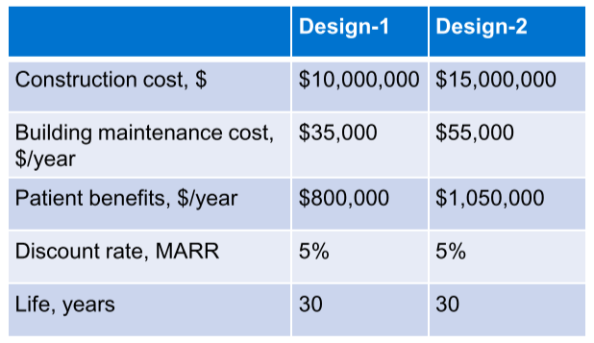
* There is also a DN alternative

Use the AW method of B/C analysis to make the selection.

Comparing Design 1 and Do Nothing:

$$AW_{1B}=\$800,000$$

$$AW_{1C}=\$10,000,000×(A/P,5\%,30)+\$35,000=\$10,000,000×0.0651+\$35,000=\$686,000$$

$$\frac{B}{C}=\frac{\$800,000-0}{\$686,000-0}=1.17$$

Since $\frac{B}{C}>1$, Design 1 wins over Do Nothing

Comparing Design 1 and Design 2:

$$AW_{2B}=\$1,050,000$$

$$AW_{2C}=\$15,000,000×(A/P,5\%,30)+\$55,000=\$15,000,000×0.0651+\$55,000=\$1,031,500$$

$$\frac{B}{C}=\frac{\$1,050,000-\$800,000}{\$1,031,500-\$686,000}=0.72$$

Since $\frac{B}{C}>1$, Design 1 wins over Design 2

## Sensitivity And Breakeven Methods

* **Sensitivity**: the relative magnitude of a variation in one or more elements of a problem, which is sufficient to change a particular decision
* Breakeven Method: a form of sensitivity analysis that determines the conditions where two alternatives are equivalent

Example:

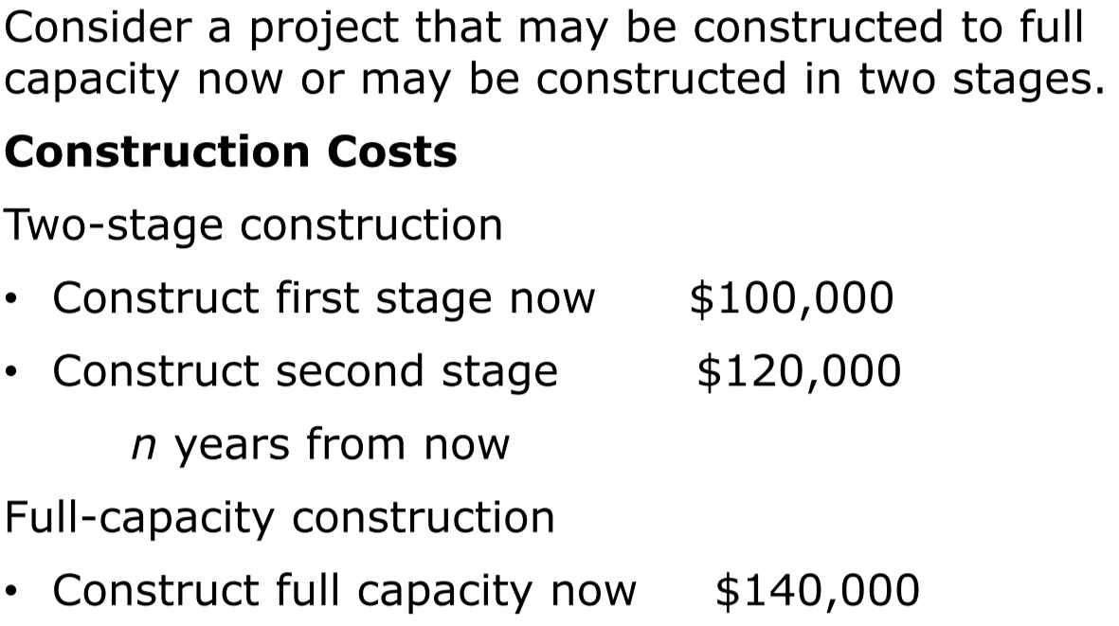

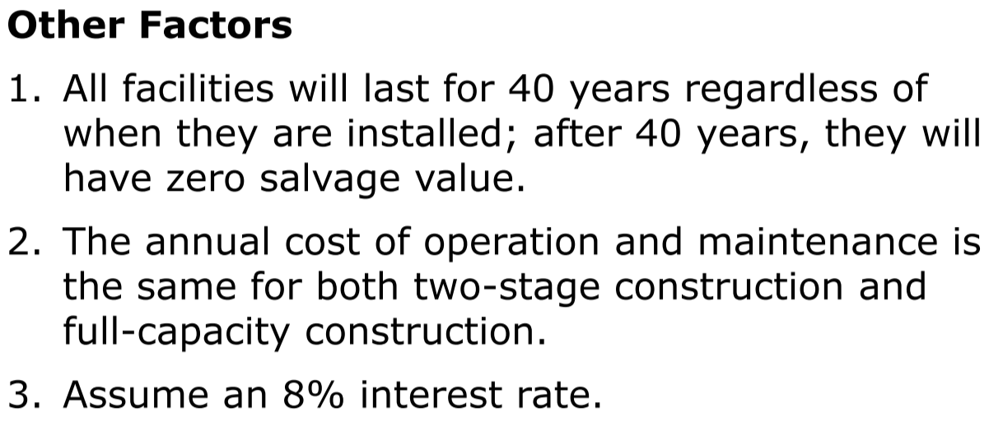

* Plot "age when second stage is constructed" versus "costs for both alternatives."
* Mark the breakeven point on your graph.
* What is the sensitivity of the decision to second-stage construction 16 or more years in the future?

Full-capacity construction: $PW=\$140,000$

Two-stage construction: need to compute $PW$ for several $n$

$$n=5:PW=\$100,000+\$120,000\left(P/F,8\%,5\right)=\$100,000+\$120,000×0.6806=\$181,672$$

$$n=10:PW=\$100,000+\$120,000×0.4632=\$155,584$$

$$n=20:PW=\$100,000+\$120,000×0.2145=\$125,740$$

$$n=30:PW=\$100,000+\$120,000×0.0994=\$111,928$$

From the breakeven chart:

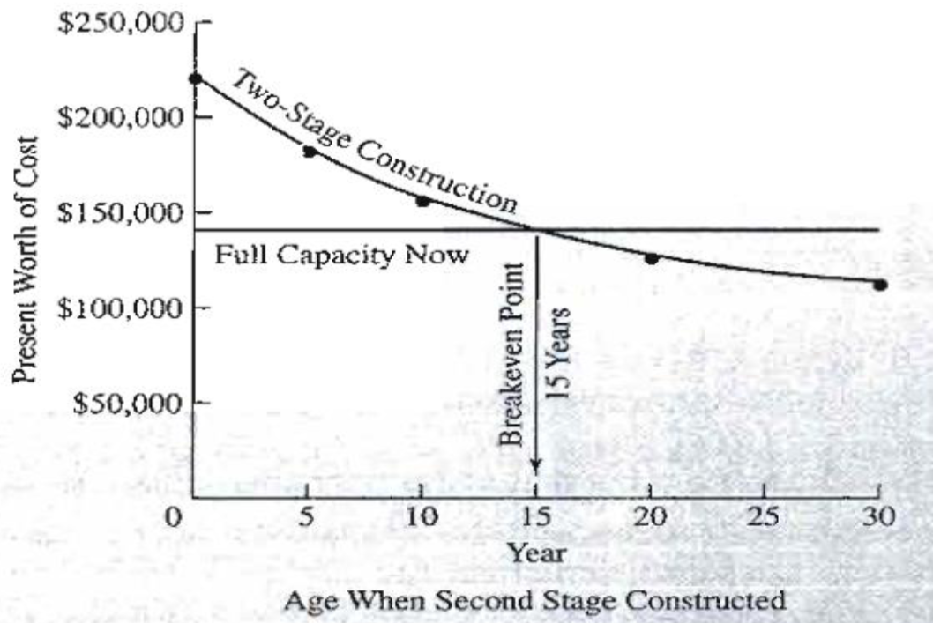

* 15 years is the breakeven point, where both alternatives have equivalent costs
* If the second stage is needed before 15 years, two-stage construction has higher PW cost, so one-stage construction is preferred; after 15 years, two-stage construction is preferred
* The decision on how to construct the project is sensitive to the age only if 15 years is within the range of estimates
* Hence, the decision isn’t sensitive to second-stage construction 16 or more years in the future – it is always the better choice

# Depreciation

The general decrease in utility of fixed assets with use and time

* Economic depreciation: gradual decrease in asset of a utility, with use and time
  + **Physical depreciation**
  + **Functional depreciation**
* Accounting depreciation: systematic allocation of an asset’s value in portions over its depreciable life, after being used in engineering economic analysis
  + **Book depreciation**
  + **Tax depreciation**
  + Unlike maintenance/material/labour costs, costs of **affixed assets** are capitalized – the costs are distributed by subtracting them as expenses from the year’s income
* Depreciable life **(accounting/asset depreciation)**: systematic allocation of an asset’s initial cost in parts over time
* Cost basic: total cost that is claimed as expense over an asset’s life – the sum of the annual depreciation expenses
  + Includes actual cost and incidental expenses
* Useful life: estimate of the duration over which the asset is expected to fulfill its intended service
* Salvage value: the asset value at the end of its lifetime – amount recovered through sale/trade-in/salvage, or net disposal costs
* Scrap value: the actual value of an asset at the end of its physical life (when it is broken up for the material value of its pats), or an estimate based on a depreciation model
* Market value: the actual value of an asset in an open market
* Book value: the depreciated value of an asset for accounting purposes, as calculated with a deprecation model

## Straight-Line Depreciation

**Annual depreciation charge:**

$$d_{1}=\frac{B-S}{N}$$

**Book value after $n$ years**:

$$BV_{n}=B-\frac{n\left(B-S\right)}{N}$$

* $B$ = cost of asset, including installation costs
* $S$ = salvage value at end of asset’s useful life
* $N$ = useful life

Example:

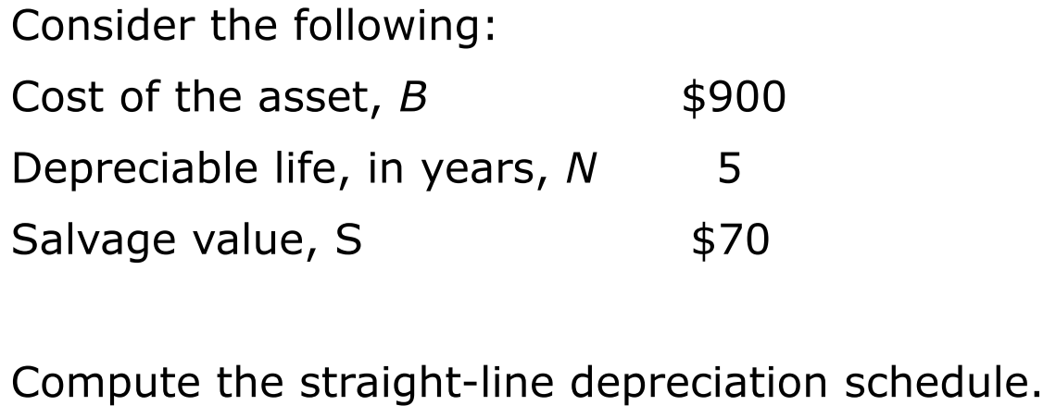

$$Annual depreciation charge=\frac{B-S}{N}=\frac{\$900-\$70}{5}=\$166$$

|  |  |  |  |
| --- | --- | --- | --- |
| **Year** | **Depreciation** | **Cumulative Depreciation** | **Book Value at end of year** |
| 1 | $166 | $166 | $734 |
| 2 | $166 | $332 | $568 |
| 3 | $166 | $498 | $402 |
| 4 | $166 | $664 | $236 |
| 5 | $166 | $830 | $70 = $S$ |

## Accelerated Methods

These methods recognize that the stream of service provided by a fixed asset may decrease over time – the stream may be greatest in its first year and least in its last year

### Declining Balance (DB) Method

* Models loss in value of an asset as a constant fraction of the asset’s current value
* Depreciation charge is a constant proportion of its closing book value from the previous period

**Depreciation charge**:

$$D_{1}=d×P$$

$$D_{2}=d×\left(P-D_{1}\right)=d×P(1-d)$$

$$D_{3}=d×\left(P-D_{2}\right)=d×P{\left(1-d\right)}^{2}$$

$$D_{n}=d×P{\left(1-d\right)}^{n}$$

**Book value**:

$$BV_{db}^{n}=S=P{\left(1-d\right)}^{n}$$

**Depreciation rate**:

$$d=1-\sqrt[n]{\frac{S}{P}}$$

* $P$ = purchase price of asset on the current market

**Total declining balance depreciation**:

$$TDB_{n}=D_{1}+D_{2}+…+D_{n} \\ =P[1-{\left(1-d\right)}^{n}]$$

Example:

* Sarah wants to estimate the salvage value of a coffee shop 20 years after purchase.
* She feels that the depreciation is best represented using the declining-balance method, but she doesn't know what depreciation rate to use.
* She observes that the purchase price of the coffee shop was $245,000 three years ago, and an estimate of its current salvage value is $180,000.

What is a good estimate of the value of the coffee shop after 20 years?

$$d=1-\sqrt[3]{\frac{\$180,000}{\$245,000}}=0.097663$$

$$BV_{db}^{n}=\$245,000{\left(1-0.097663\right)}^{20}=\$31,372$$